SIMATS ENGINEERING ASSESSMENT TOOL 2: Case Study
NAME: B PRAVEEN KUMAR REG NO:192511135
COURSE NAME: Cloud Computing and Big Data Analytics COURSE CODE: CSA1506

1. Case Study 1: Smart Retail Inventory Management System
A retail chain implements a cloud-based inventory system connected to store devices.Clients (POS systems and dashboards) communicate via APIs to centralized cloud services. Cloud
storage stores product data, transaction logs, and analytics datasets. The system uses platform services for analytics and demand forecasting. Secure access is maintained through VPNs, firewalls, and API gateways.This solution integrates infrastructure, services, and web
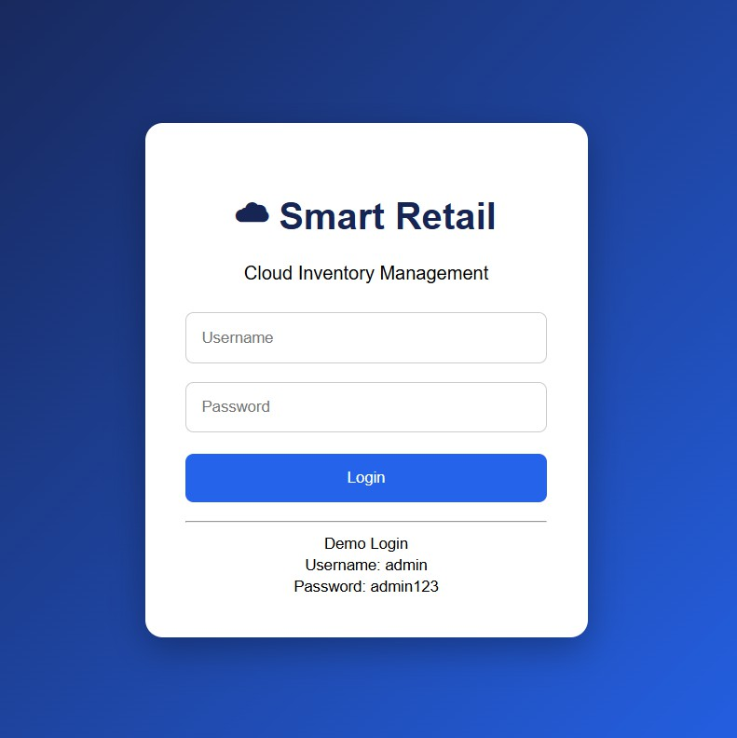
applications for efficient operations.

